CYBER SECURITY LONG-TERM INTERNSHIP



Technology Stack: Cyber security with IBM QRadar

Project Title: Leveraging real-time security intelligence for enhanced defence.

Team ID : LTVIP2024TMID14828

Team Size : 4

Team Leader : Mahalakshmi Talabakthula

Team member : Palepu Divya

Team member: pinapothu bhavani

Team member: Arava Anusha

Register number : SBAP0014840

College: A.S.D GOVT DEGREE COLLEGE FOR WOMEN (A) KAKINADA.

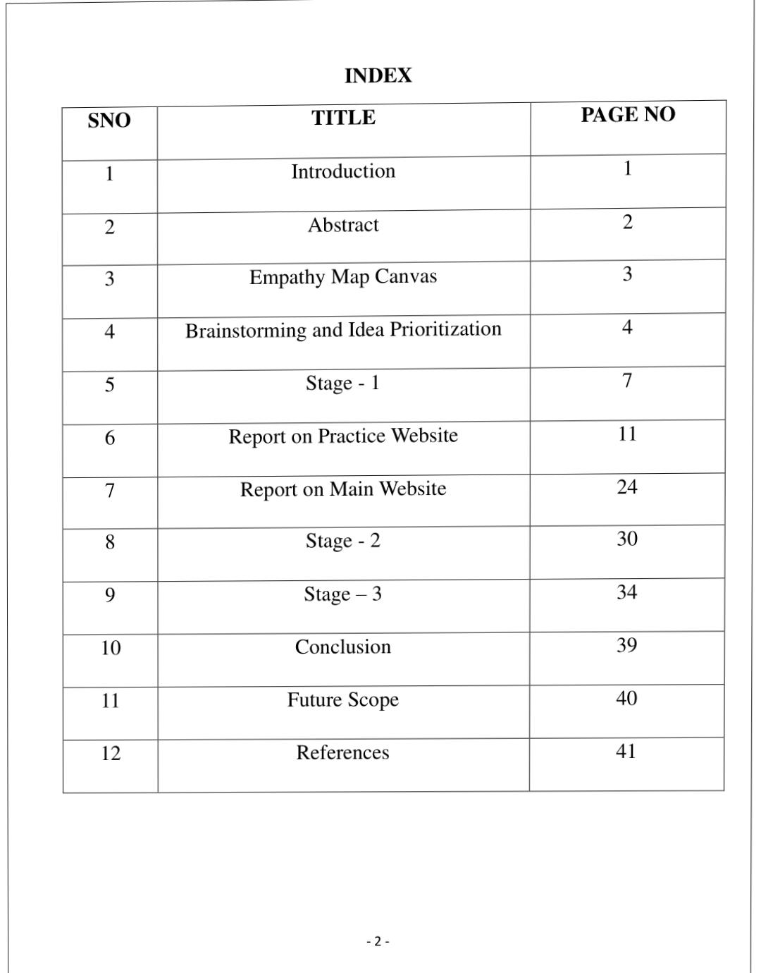

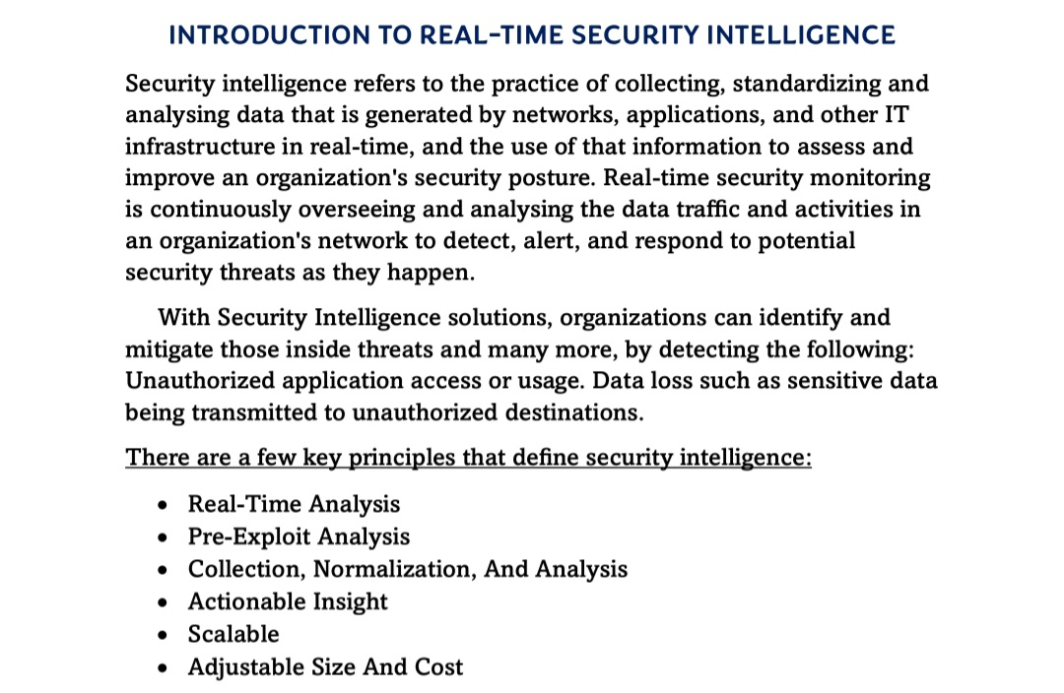

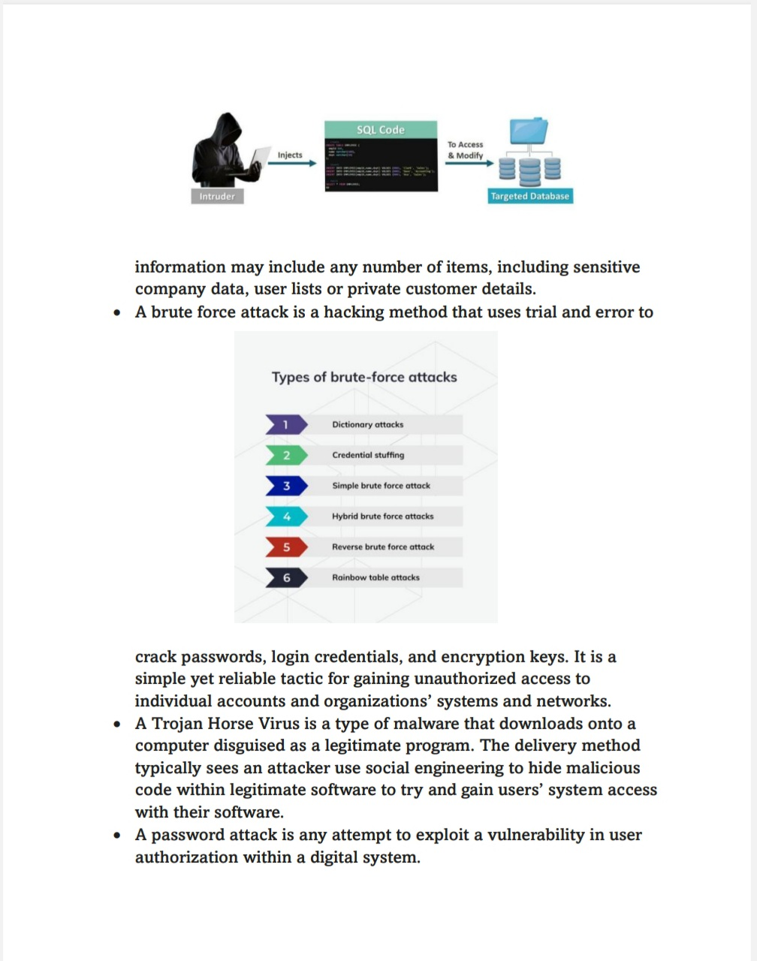

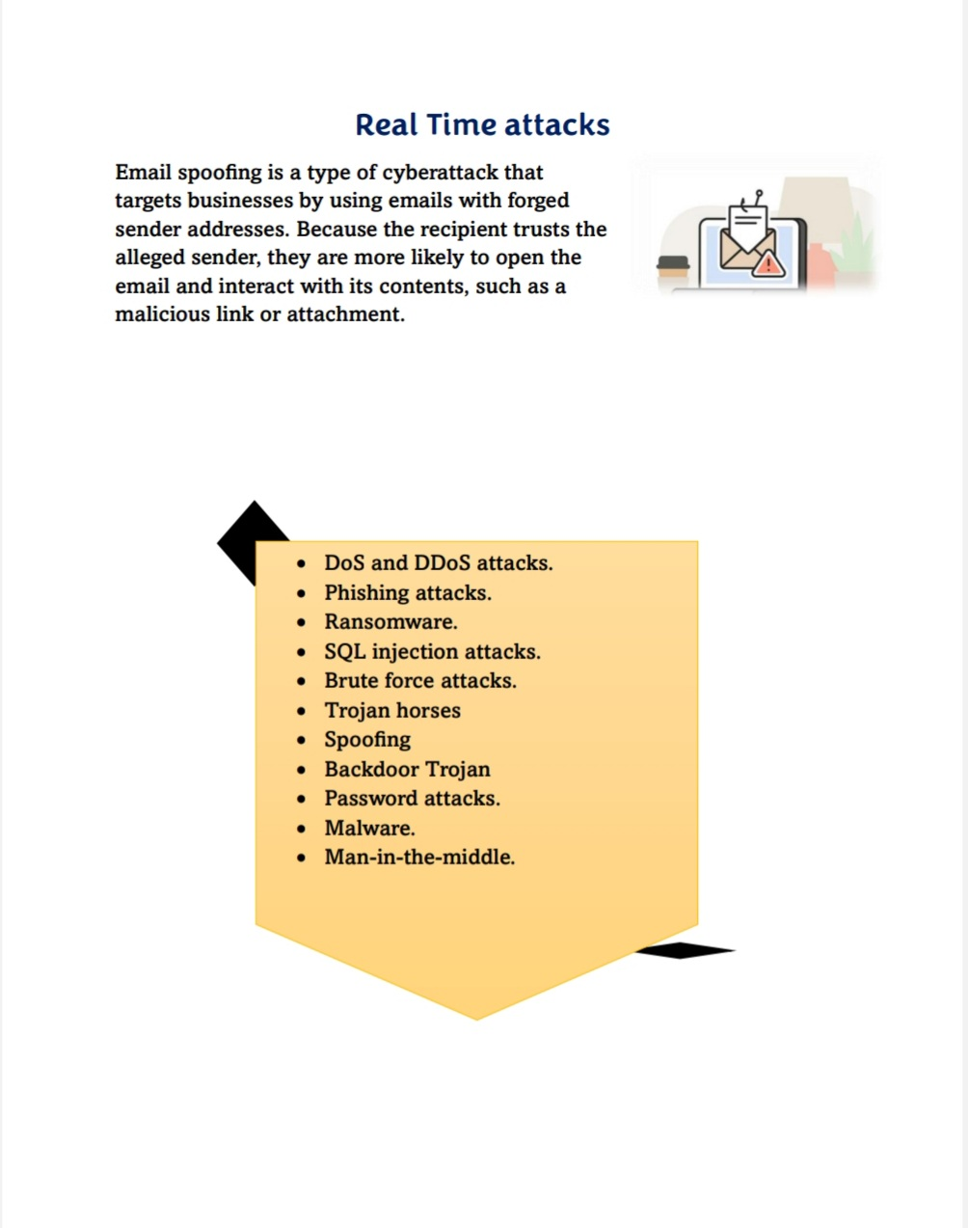

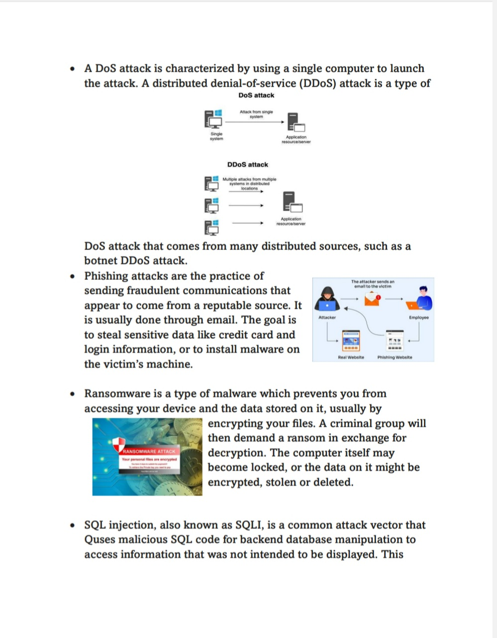

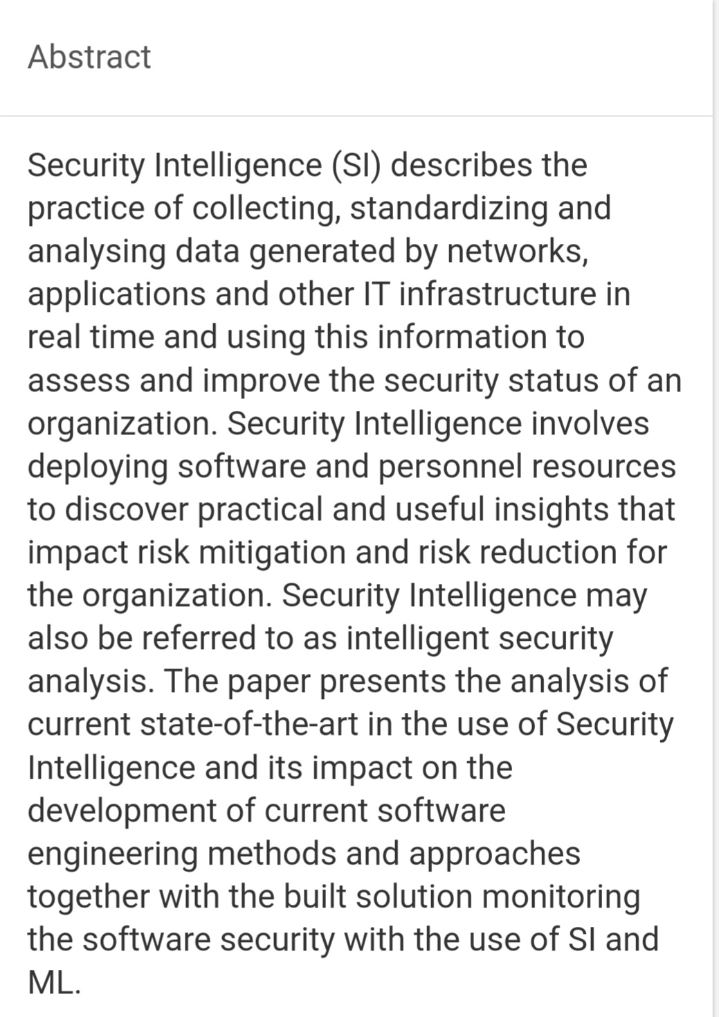

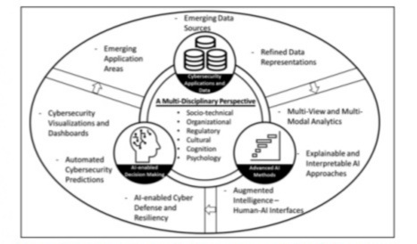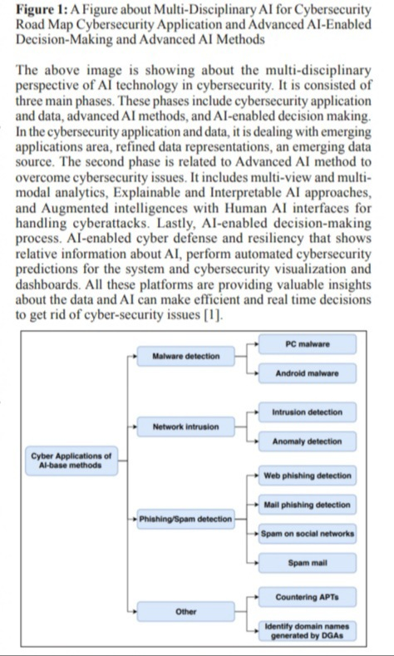S

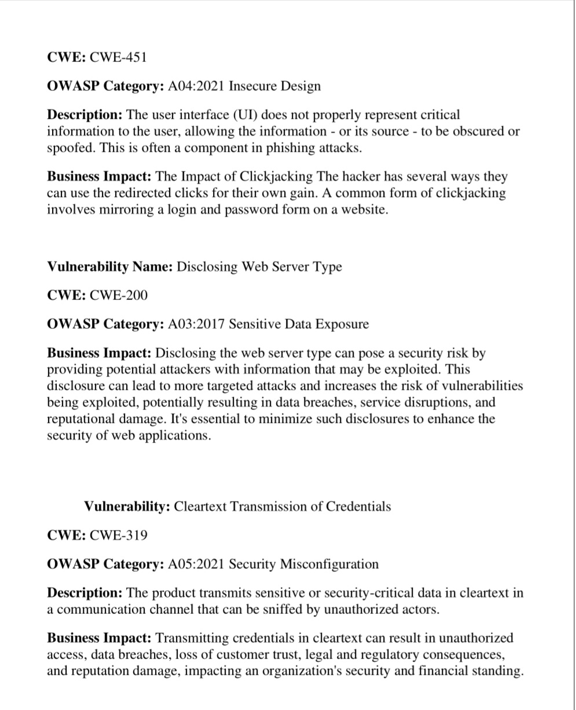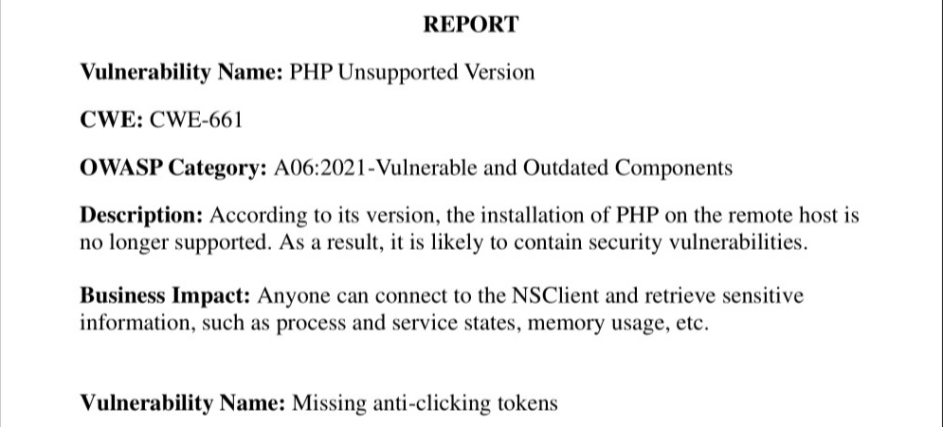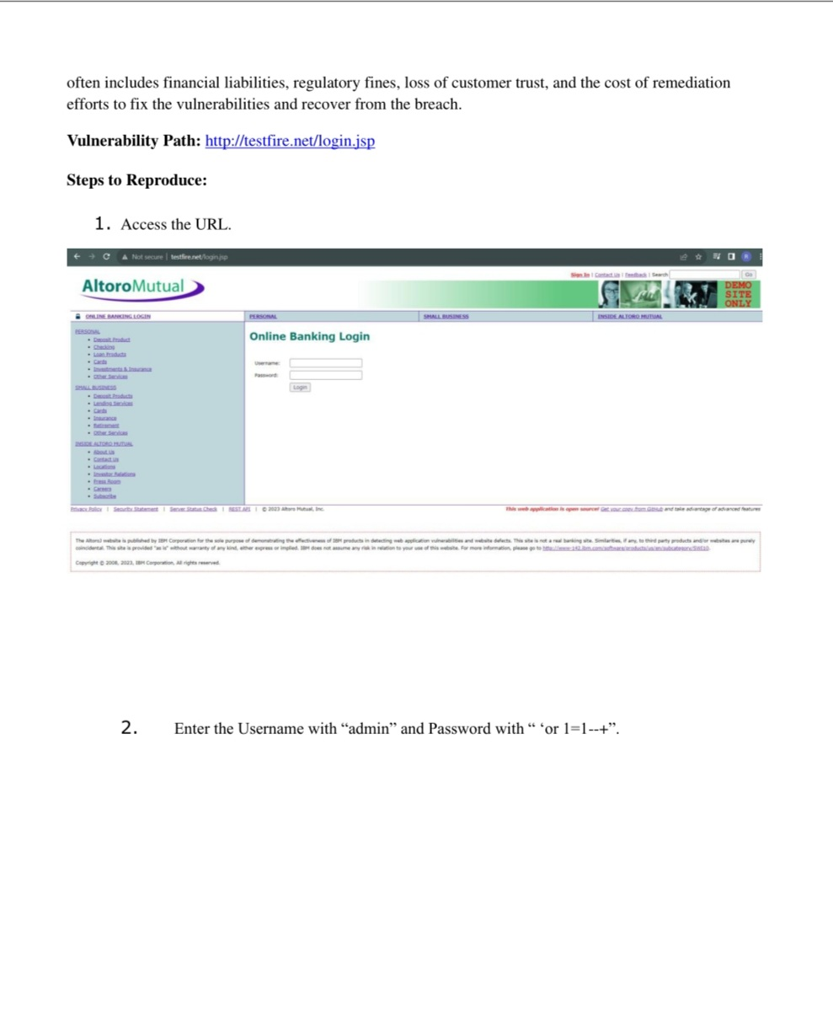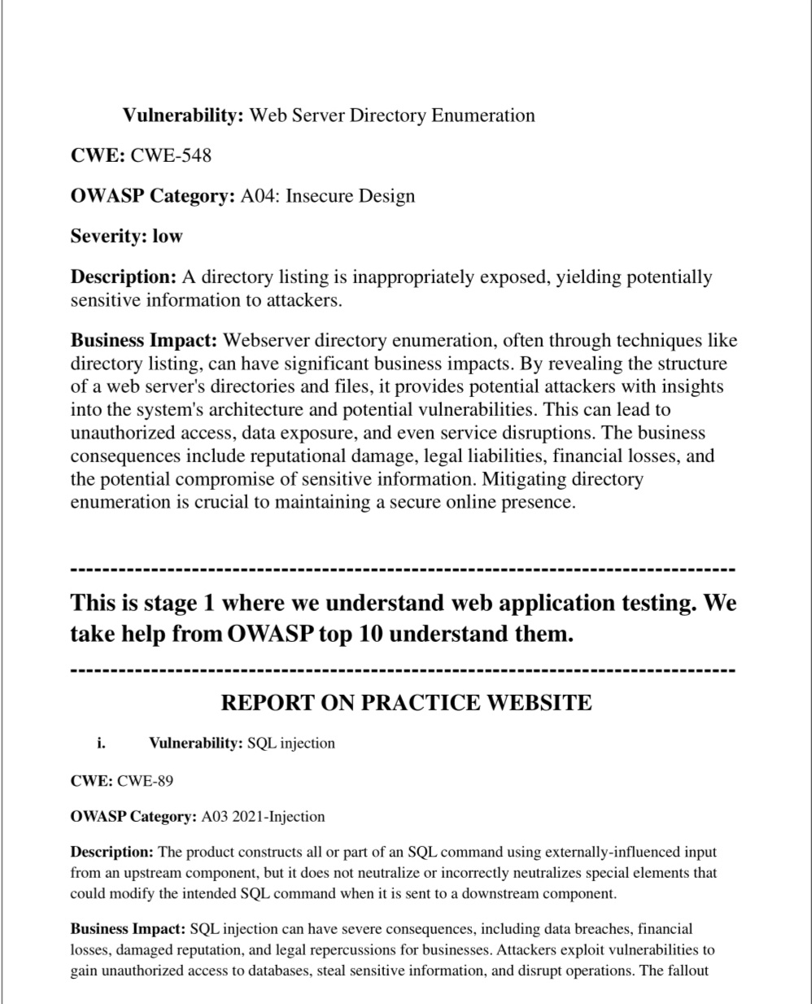I

